Power BI – Module End Evaluation Documentation
Data Cleaning, Visualizations & DAX Calculations
Dataset: SalesData_1000Rows_WithIssues_copy.csv
Q1: Data Cleaning and Loading
I imported the dataset into Power Query and cleaned it before loading it into Power BI. The main goal was to make the data consistent and ready for analysis.
1. Import Dataset
- Home → Get Data → Text/CSV.
- Select SalesData_1000Rows_WithIssues_copy.csv.
- Click Transform Data to open Power Query Editor.

2. Handle Missing CustomerName
Some CustomerName values were missing, so I replaced them with “Unknown”. This allowed me to keep the order records instead of deleting them.
- Select CustomerName.
- Transform → Replace Values.
- Replace the missing/null value with Unknown.
- Click OK and verify.
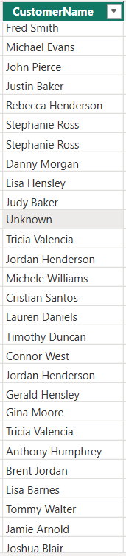

3. Handle Other Missing Values
For other missing values, I used a suitable approach based on the type of column. For text fields such as Region and Product, missing values were marked as “Unknown”.
4. Remove Duplicate Rows
I removed duplicate records to make sure the same order was not counted twice during the analysis.
- Select all columns.
- Home → Remove Rows → Remove Duplicates.
- Verify that duplicate records were removed.

5. Standardize OrderDate
The OrderDate column initially showed errors when I tried to change it directly to Date. I first converted the values safely and then changed the column to the Date data type.
- Set OrderDate to Text if required.
- Add Column → Custom Column.
- Create a cleaned date using: try Date.FromText([OrderDate], "en-GB") otherwise null.
- Check the cleaned dates for errors.
- Remove the original OrderDate column and rename the cleaned column to OrderDate.
- Transform → Data Type → Date.
- Confirm the column is Date with no errors.
I used the en-GB format because the dates in the dataset follow the day-month-year (DD-MM-YYYY) format.
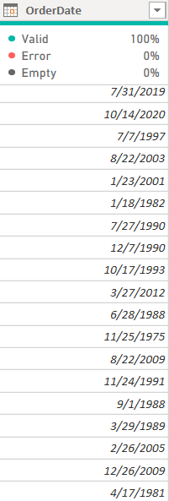

6. Remove Missing OrderDate Values
I removed rows with missing OrderDate values because an order without a date cannot be correctly placed on the profit trend over time.
- Open the OrderDate filter.
- Identify (null)/(blank) values.
- Uncheck the blank/null value and click OK.
- Check Column Quality for no empty or error values.

7. Load Cleaned Data
After completing the cleaning, I selected Home → Close & Apply to load the cleaned data into Power BI.

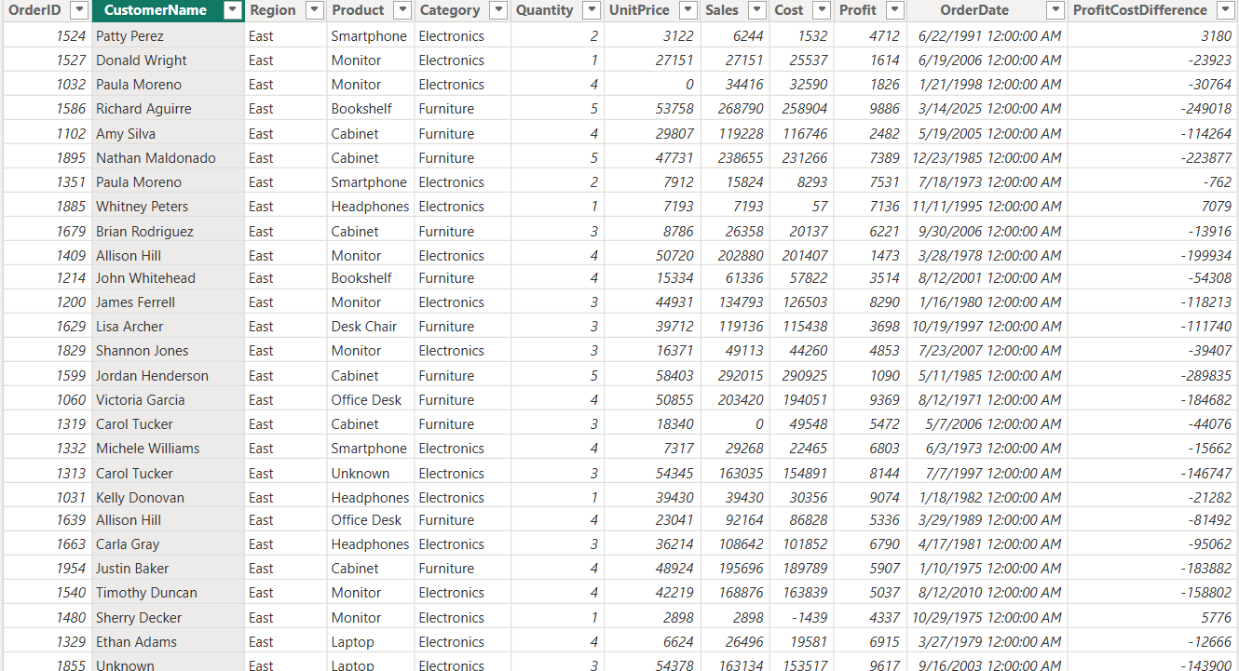

Q2: Visualizations and Insights
After cleaning the data, I created three visuals to understand the orders, popular products, and profit trend.
1. Pie Chart – Order Distribution by Region
Purpose: Show the distribution of orders across regions.
- Report View → Pie Chart.
- Region → Legend.
- OrderID → Values, using Count of OrderID.
- Turn on data labels and title the visual “Order Distribution by Region”.

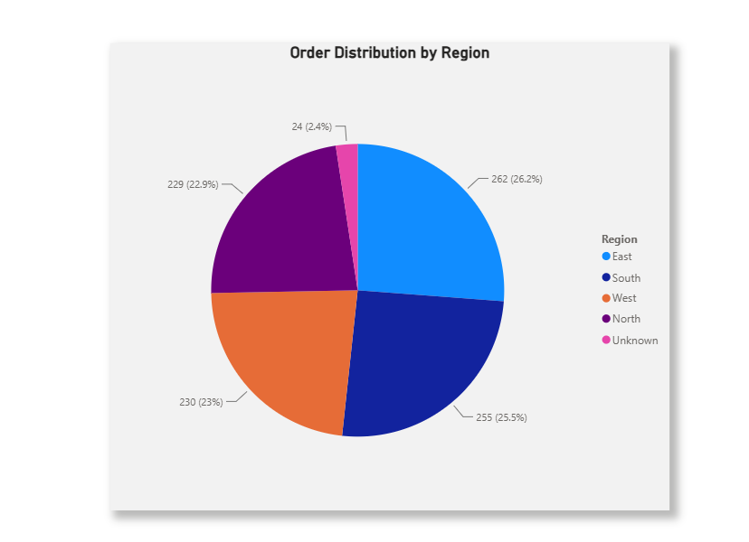

2. Column Chart – Top 5 Trending Products
Purpose: Identify the five products ordered most frequently.
- Insert a Clustered Column Chart.
- Product → X-axis.
- OrderID → Values, using Count of OrderID.
- Sort Count of OrderID descending.
- Filters on this visual → Product → Top N → Top 5, using Count of OrderID.
- Title: “Top 5 Trending Products by Order Count”.

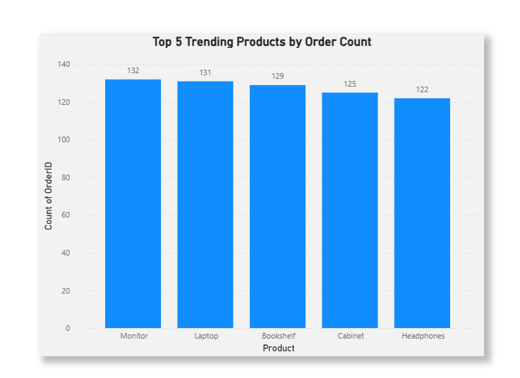

3. Line Chart – Profit Trend Over Time
Purpose: Show how profit changes over time.
- Insert a Line Chart.
- OrderDate → X-axis. Use the actual Date field if a hierarchy appears.
- Profit → Y-axis, using Sum of Profit.
- Sort OrderDate ascending.
- Title: “Profit Trend Over Time”.

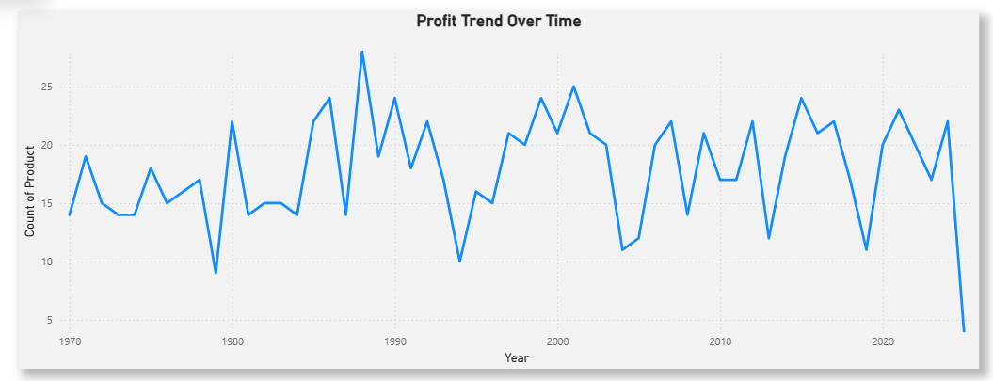

Q3: DAX Calculations
I used DAX to create a calculated table, a calculated column, and a measure for further analysis.
1. Calculated Table – EastRegionOrders
Purpose: Create a table containing only orders from the East region.
Table tools → New table:
EastRegionOrders =
FILTER(
SalesData,
SalesData[Region] = "East"
)
Replace SalesData with the exact name of your cleaned table if it is different.
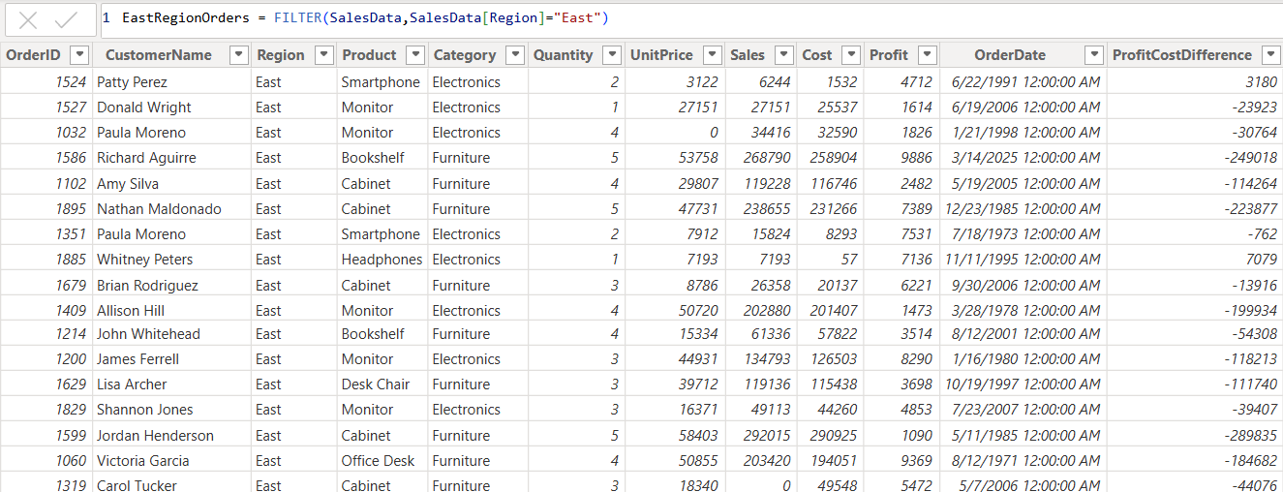

2. Calculated Column – ProfitCostDifference
Purpose: Calculate the difference between Profit and Cost for each row.
Table tools → New column:
ProfitCostDifference =
SalesData[Profit] - SalesData[Cost]
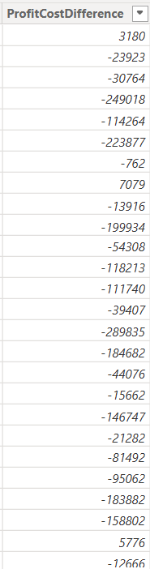

3. Measure – TotalProfit
Purpose: Calculate the total profit earned.
Table tools → New measure:
TotalProfit =
SUM(SalesData[Profit])
The measure updates automatically when filters or selections are applied in the report.

Final Checklist
Section | Completed Task
Q1 | Import, clean, and load dataset
Q1 | Handle missing values
Q1 | Remove duplicate rows
Q1 | Standardize OrderDate
Q2 | Pie Chart – Region distribution
Q2 | Column Chart – Top 5 products
Q2 | Line Chart – Profit trend
Q3 | EastRegionOrders calculated table
Q3 | ProfitCostDifference calculated column
Q3 | TotalProfit measure

